| Cybersecurity |
| --- |
| Project 1 Technical Brief |

Make a copy of this document before you begin. Place your answers below   
each question. This completed document will be your deliverable for Project 1. Submit it through Canvas when you’re finished with the project at the end of the week.

## Your Web Application

Enter the URL for the web application that you created:

| https://martinarussoblog.azurewebsites.net/ |
| --- |

Paste screenshots of your website created (Be sure to include your blog posts):

|  |
| --- |

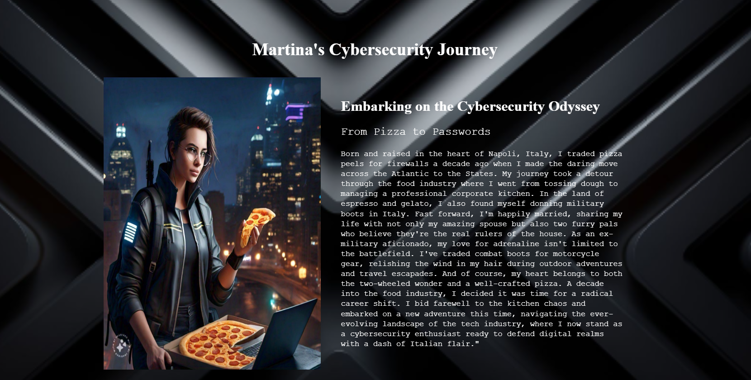

## Day 1 Questions

### General Questions

1. What option did you select for your domain (Azure free domain, GoDaddy domain)?

| 1. GoDaddy |
| --- |

1. What is your domain name?

| martinarusso.work |
| --- |

### Networking Questions

1. What is the IP address of your webpage?

| 20.119.16.47 |
| --- |

1. What is the location (city, state, country) of your IP address?

| Non-authoritative answer:  Name: waws-prod-blu-509-deb7.eastus.cloudapp.azure.com  Address: 20.119.16.47  Aliases: martinarussoblog.azurewebsites.net  waws-prod-blu-509.sip.azurewebsites.windows.net |
| --- |

1. Run a DNS lookup on your website. What does the NS record show?

| martinarussoblog.azurewebsites.net canonical name = waws-prod-blu-509.sip.azurewebsites.windows.net  waws-prod-blu-509.sip.azurewebsites.windows.net canonical name = waws-prod-blu-509-deb7.eastus.cloudapp.azure.com  eastus.cloudapp.azure.com  primary name server = ns1-201.azure-dns.com  responsible mail addr = msnhst.microsoft.com  serial = 10001  refresh = 900 (15 mins)  retry = 300 (5 mins)  expire = 604800 (7 days)  default TTL = 60 (1 min) |
| --- |

### Web Development Questions

1. When creating your web app, you selected a runtime stack. What was it? Does it work on the front end or the back end?

| Front End (css,html) |
| --- |

1. Inside the /var/www/html directory, there was another directory called assets. Explain what was inside that directory.

| css images |
| --- |

1. Consider your response to the above question. Does this work with the front end or back end?

| CSS styles web page presentation, images display content; both pertain to the front-end in web development |
| --- |

## Day 2 Questions

### Cloud Questions

1. What is a cloud tenant?

| Cloud tenant: user or organization utilizing cloud services and resources independently. web development |
| --- |

1. Why would an access policy be important on a key vault?

| Access policies on a key vault control and secure cryptographic key access. |
| --- |

1. Within the key vault, what are the differences between keys, secrets, and certificates?

| Keys handle cryptography, secrets store sensitive data, and certificates ensure secure communication and identification. |
| --- |

### Cryptography Questions

1. What are the advantages of a self-signed certificate?

| Self-signed certificates are quick and cost-effective but lack trust, making them suitable for internal use but unsuitable for public-facing sites due to potential browser warnings. |
| --- |

1. What are the disadvantages of a self-signed certificate?

| Lack of external recognition leads to trust issues, potential security risks without third-party validation, and unsuitability for production or public-facing environments. |
| --- |

1. What is a wildcard certificate?

| A wildcard certificate is a type of SSL/TLS certificate that secures a domain and its subdomains with a single certificate. |
| --- |

1. When binding a certificate to your website, Azure only provides TLS versions 1.0, 1.1, and 1.2. Explain why SSL 3.0 isn’t provided.

| SSL 3.0 is deprecated due to vulnerabilities like attacks. Azure prioritizes modern TLS versions (1.0, 1.1, 1.2) for improved security. |
| --- |

1. After completing the Day 2 activities, view your SSL certificate and answer the following questions:
   1. Is your browser returning an error for your SSL certificate? Why or why not?

| No, The WAF rules are designed to prevent any malicious SQL codes and scrutinize any attachments linked to the URL. |
| --- |

* 1. What is the validity of your certificate (date range)?

| 3/4/2025 |
| --- |

* 1. Do you have an intermediate certificate? If so, what is it?

| red-key.vault.azure.net/certificates/Red-Cert/ |
| --- |

* 1. Do you have a root certificate? If so, what is it?

| Yes, |
| --- |

* 1. Does your browser have the root certificate in its root store?

| yes |
| --- |

* 1. List one other root CA in your browser’s root store.

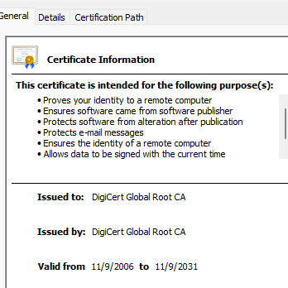

## Day 3 Questions

### Cloud Security Questions

1. What are the similarities and differences between Azure Web Application Gateway and Azure Front Door?

| Similarities: Both Azure Web Application Gateway and Azure Front Door provide load balancing, SSL termination, and application delivery.  Differences: Azure Front Door is a global service for content delivery and acceleration, while Web Application Gateway is for application delivery within a region. |
| --- |

1. A feature of the Web Application Gateway and Front Door is “SSL Offloading.” What is SSL offloading? What are its benefits?

| SSL offloading is the process of decrypting SSL/TLS-encrypted traffic at a gateway, reducing load on backend servers. Benefits include improved performance and simplified certificate managemen |
| --- |

1. What OSI layer does a WAF work on?

| Layer 7 |
| --- |

1. Select one of the WAF managed rules (e.g., directory traversal, SQL injection, etc.), and define it.

| SQL Injection is a cyber attack injecting malicious SQL code into web app inputs, exploiting poor validation, risking unauthorized database access. |
| --- |

1. Consider the rule that you selected. Could your website (as it is currently designed) be impacted by this vulnerability if Front Door wasn’t enabled? Why or why not?

| Configure a custom WAF rule in Azure named "Project1rule" with a priority of 100. Use geo-location conditions to deny traffic from all countries except USA, Canada, and Australia. Exercise caution to prevent unintended consequences and conduct thorough testing before deploying to production. |
| --- |

1. Hypothetically, say that you create a custom WAF rule to block all traffic from Canada. Does that mean that anyone who resides in Canada would not be able to access your website? Why or why not?

| Yes, creating a custom WAF rule to block all traffic from Canada would likely prevent anyone residing in Canada from accessing your website. The rule would indiscriminately block traffic based on the specified criteria, in this case, the geographical location (Canada). |
| --- |

1. Include screenshots below to demonstrate that your web app has the following:
   1. Azure Front Door enabled

|  |
| --- |

* 1. A WAF custom rule

|  |
| --- |

## Disclaimer on Future Charges

Please type “**YES**” after one of the following options:

* ***Maintaining website after project conclusion****: I am aware that I am responsible for any charges that I incur by maintaining my website. I have reviewed the* [*guidance*](https://docs.google.com/document/d/1ZzC4oTJFdlkkeWuzuJAyVSqtDFbuAWilmwXg8PZgzMs/edit) *for minimizing costs and monitoring Azure charges.*
* ***Disabling website after project conclusion****: I am aware that I am responsible for deleting all of my project resources as soon as I have gathered all of my web application screen shots and completed this document.*

© 2022 Trilogy Education Services, a 2U, Inc. brand. All Rights Reserved.